Active Directory Lab 04
Configuring Shared Folders and Access Permissions in Active Directory
Objective
The objective of this lab was to configure secure shared folders in a Windows Server environment using Active Directory security groups. The lab demonstrated how to create shared folders, configure both Share and NTFS permissions, and verify that users could access only the resources assigned to their departmental roles. This exercise provided practical experience in implementing secure file sharing and access control based on the principle of Role-Based Access Control (RBAC).

Lab Environment
Component | Details
Operating System | Windows Server (Domain Controller)
Client Machine | Windows 11
Virtualization | VMware Workstation / VirtualBox
Domain | mydomain.com
Tool Used | Active Directory Users and Computers (ADUC), File Explorer

Step 1: Creating Departmental Shared Folders
A new directory named Shares was created on the Domain Controller under the *C:* drive. Inside this directory, three departmental folders were created to represent the IT, HR, and Sales departments.
The resulting folder structure was as follows:
C:\Shares\
├── IT\
├── HR\
└── Sales\
These folders were prepared to serve as centralized shared resources for their respective departments.

Result
The departmental folder structure was successfully created on the Domain Controller.
Screenshot 1: Departmental Folder Structure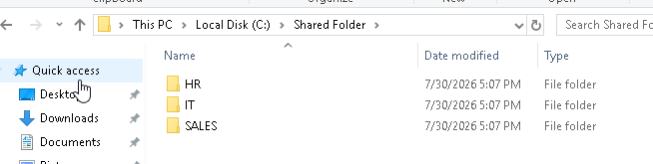

Step 2: Configuring Shared Folder Permissions
Each departmental folder was configured as a shared folder using the Advanced Sharing option in Windows. The default Everyone permission was removed, and access was granted only to the corresponding Active Directory security group.
The configured share permissions were as follows:
Shared Folder | Security Group | Share Permission
IT | IT_Team | Full Control
HR | HR_Team | Full Control
Sales | Sales_Team | Full Control
Although Full Control was assigned at the share level, detailed access control was managed through NTFS permissions.
Result
All departmental folders were successfully shared and configured with department-specific share permissions.

Screenshot 2: Shared Folder Configuration
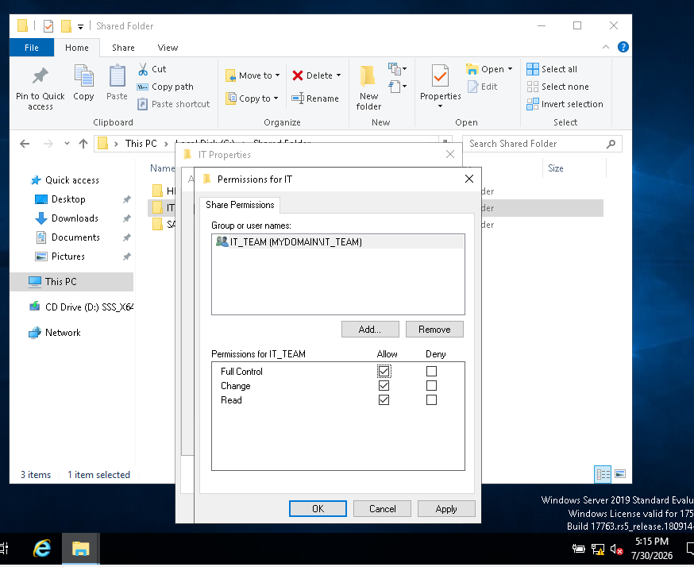
Step 3: Configuring NTFS Permissions
To provide more granular access control, NTFS permissions were configured on each departmental folder. The corresponding security group was granted permissions to read, view folder contents, and create new files while preventing unrestricted administrative control.
The following permissions were assigned:
- Read & Execute
- List Folder Contents
- Read
- Write
The Users group was removed from each folder to prevent unauthorized access by other domain users.
Result
NTFS permissions were successfully configured, ensuring that only authorized departmental users could access and modify their respective folders.
Screenshot 3: NTFS Permission Configuration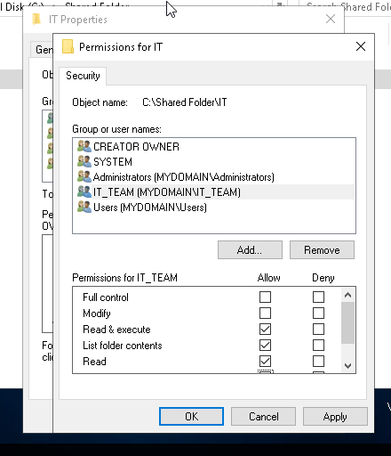
Step 4: Verifying Access as an IT User
The Windows 11 client machine was used to log in with the john.doe account, a member of the IT_Team security group.
The following access tests were performed:
Shared Folder | Result
\\172.16.0.1\IT | Access Granted
\\172.16.0.1\HR | Access Denied
\\172.16.0.1\Sales | Access Denied
A text file was successfully created inside the IT shared folder, confirming that the assigned write permissions were functioning correctly. 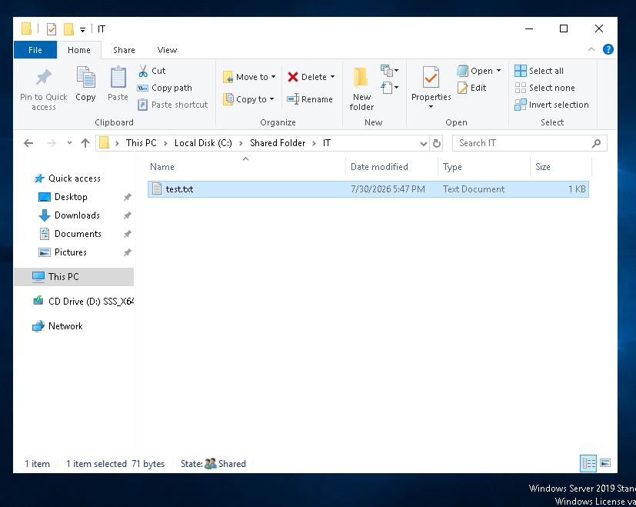
Result
The IT department user successfully accessed and modified the IT shared folder while being denied access to other departmental folders.
Screenshot 4: IT User Access Verification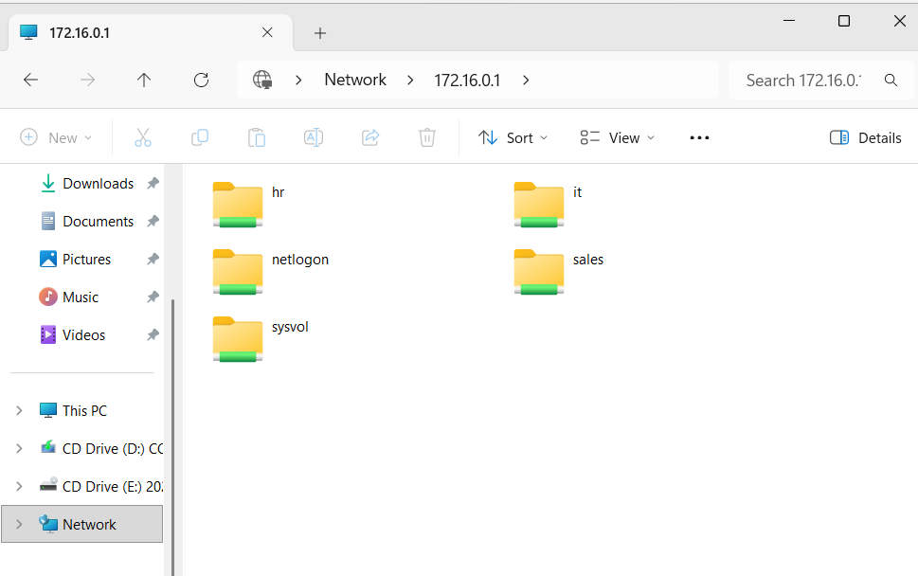

Step 5: Verifying Access as an HR User
The client machine was then logged in using the jane.smith account, which belongs to the HR_Team security group.
The following access tests were completed:
Shared Folder | Result
\\172.16.0.1\HR | Access Granted
\\172.16.0.1\IT | Access Denied
\\172.16.0.1\Sales | Access Denied
The successful access to the HR shared folder confirmed that permissions were correctly assigned based on departmental membership.
Result
The HR user was able to access only the HR shared folder while access to other departments remained restricted.

Step 6: Verifying Access as a Sales User
The client machine was logged in using the bob.wilson account, a member of the Sales_Team security group.
The following access results were observed:
Shared Folder | Result
\\172.16.0.1\Sales | Access Granted
\\172.16.0.1\IT | Access Denied
\\172.16.0.1\HR | Access Denied
The test confirmed that the Sales department user could access only the Sales shared folder.
Result
Department-specific access control was successfully enforced for the Sales department.

Step 7: Verifying Access as the Domain Administrator
Finally, the Windows 11 client was logged in using the mydomain\Administrator account. Access tests were performed on all departmental shared folders.
The following results were observed:
Shared Folder | Result
\\172.16.0.1\IT | Access Granted
\\172.16.0.1\HR | Access Granted
\\172.16.0.1\Sales | Access Granted
The administrator account had unrestricted access to all shared resources because it is a member of the Domain Admins group, which possesses full administrative privileges across the domain.
Result
The Domain Administrator successfully accessed all shared folders, confirming that administrative privileges override departmental restrictions.

Conclusion
This lab demonstrated the implementation of secure file sharing in a Windows Server environment using Active Directory security groups. Department-specific shared folders were successfully created, and both Share and NTFS permissions were configured to enforce Role-Based Access Control (RBAC). Access testing confirmed that users could access only the folders assigned to their respective departments, while unauthorized access attempts were denied. The Domain Administrator retained unrestricted access to all shared resources, illustrating the hierarchy of administrative privileges within Active Directory. This exercise reinforced the importance of combining Share and NTFS permissions to implement secure and centralized file access management in enterprise environments.

